Knapsack problem

1. This knapsack problem includes eleven different items. Each item has an id, benefit, and weight.
2. The representation of the solution looks like this:

*x = {x1, x2,..,..,xn}*

n = 11

1. What we want to maximize in this problem, is the benefit. We always look after the item which has the best benefit.
$$\sum{bi}$$

2. The knapsack problem is restricted to each items weight because the knapsack has a limit of how much weight it can carry.
$$\sum{wi≤W }$$

3. In the knapsack-program, we are using two different algorithms, breadth-first, and depth-first, to find the best path.
4. Comparison of the time expended by the algorithms.

|  |  |  |
| --- | --- | --- |
| Round | DFS | BFS |
| 1 | 12 ms | 6 ms |
| 2 | 7 ms | 6 ms |
| 3 | 5 ms | 5 ms |
| 4 | 6 ms | 5 ms |
| 5 | 5 ms | 5 ms |
| 6 | 9 ms | 7 ms |

As we see in the table above in almost all cases, *Breadth_First* executes faster than *Depth_First*. And in those cases, it is not faster, both algorithms have the same execution time. In the table above, it is two times out of 6 possible times that *BFS* and *DFS* have the same execution time, which makes *BFS* faster in 33 % of the cases.

1. **Comparison of the space used in memory at a time by the algorithms.**

The algorithms are using almost the same amount of memory, but *Depth_First* are using a very small amount more. *Breadth_First* are using 492,06 kb and *Depth_First* are using 492,09 kb. So *Depth_First* are only using 0,3 more kb.

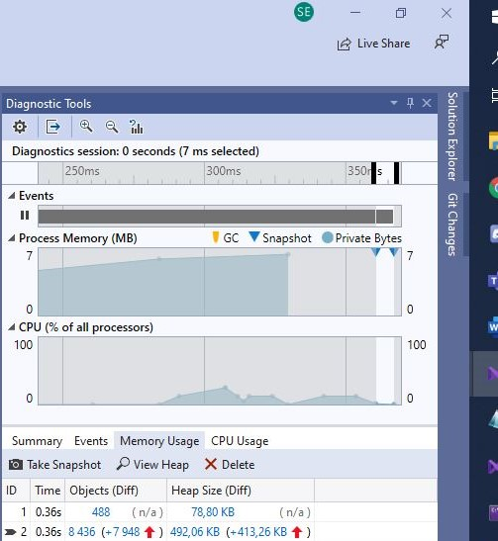

Figure : Breadth_First

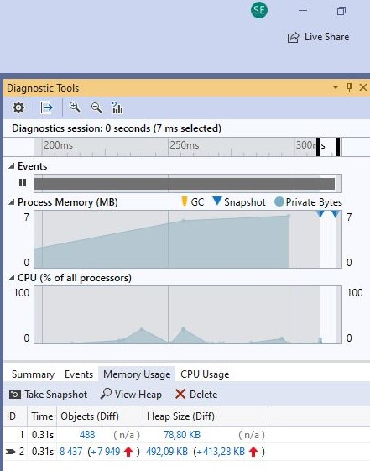

Figure : Depth_First